**Predictive Maintenance for Industrial Equipment**

**Using IoT Data**

**Introduction**

The Predictive Maintenance model for industrial equipment which utilizes IoT data is designed to forecast potential equipment failures before they occur, enhancing operational efficiency and minimizing downtime.

Leveraging real-time sensor data from machinery, the model processes and analyzes critical parameters . It applies machine learning techniques to predict the likelihood of equipment failure, enabling proactive maintenance.

In addition to predictive analysis, the model incorporates anomaly detection and real-time monitoring, allowing for immediate identification of irregular behavior. This system provides businesses with cost savings by optimizing maintenance schedules, reducing unplanned downtime, and improving overall equipment life cycle management.

**Dashboard (created in Power BI)**

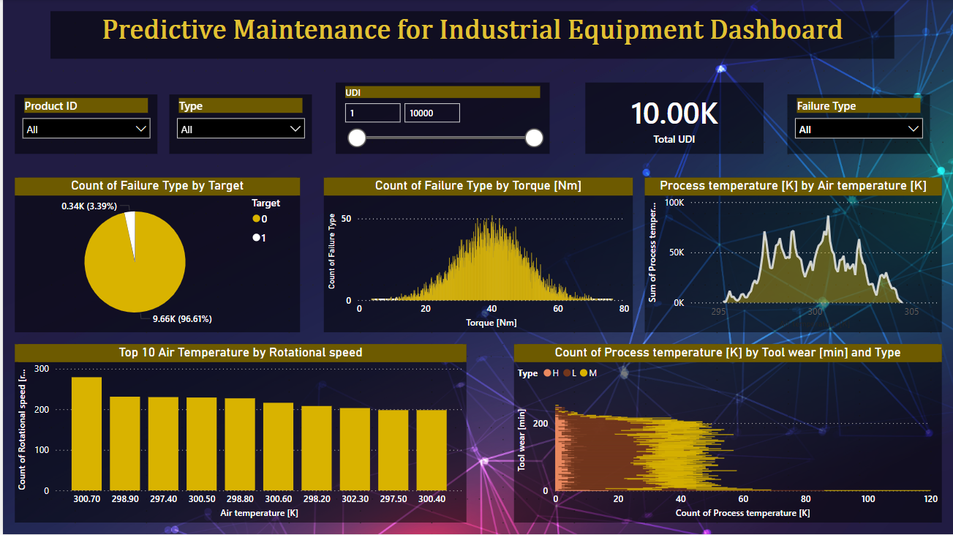

**Data Collection**

Used IoT sensors data from industrial equipment which includes equipment's telemetry and features, such as Air temperature, Process Temperature[k], Tool wear[min], and Failure type, UID’s respective to their type, model and age of the target, failures of the product, and maintenance of the machines are tracked over time for each machine.

**Key Considerations**

* **Data Quality:** The accuracy and completeness of your data will significantly impact the reliability of your predictions.
* **Model Evaluation:** Regularly evaluate and refine your machine learning models to ensure they are performing as expected.
* **Alerting and Notifications:** Set up alerts to notify relevant personnel when equipment is at risk of failure or maintenance is overdue.
* **Continuous Improvement:** Continuously monitor and refine your dashboard to incorporate new insights and improve decision-making.